PART I: BEFORE VIEWING
La grande bellezza - The Great Beauty (look up missing info on IMDb)
Director:___________________
Year:

Cast
Character Actor/ Actress
Jep Gambardella
Romano
Ramona
Alfredo
Stefania
Anna Della Rosa
Arturo
Talia Concept
Carmelina
Cardinale
Santa

1) Watch the English language trailer to La grande bellezza/ The Great Beauty (https://www.youtube.com/watch?v=Dyt430YkQn0). Who do you imagine the characters to be (occupations, relations/interrelations, challenges/solutions)? What do you think La grande bellezza will be about? Write a minimum of 3-5 sentences.

PART II: WHILE VIEWING

1) Pick one technique/element to focus on: music/sound, camerawork, symbolism/iconography. Describe how this technique/element is used in one scene. Be sure to jot down the minutes so you can re-view it and expand upon this response after viewing the film in its entirety. Write a minimum of 7-10 sentences.

PART III: After Viewing

1) Jep Gambardella (Toni Servillo) and Romano (Carlo Verdone) appear in a handful of scenes together. Focusing in particular on the episode at Romano’s studio apartment (40:33- 46:54; 2:09:00- 2:13:06; see Fig. 1 & Fig. 2) and recurring references to Elisa, Jep’s first love, that haunt the film narrative in photographs and fragmented flashbacks (36:20- 41:35; see Fig. 3, Fig. 4 & Fig. 5), do you believe these onscreen characters incarnate the qualities on the ‘Sorrentinian subject’ discussed during class (“The ‘Primal Scene’,” p. 381)? What about, Alfredo, Elisa’s widowed husband? What do these men appear to value? Write 5-7 sentences.
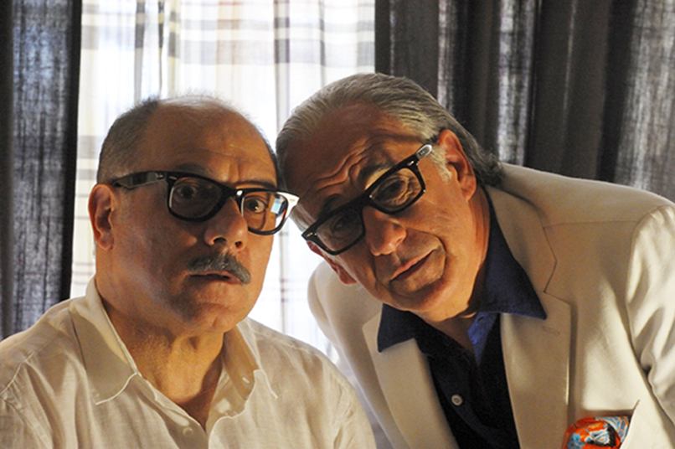
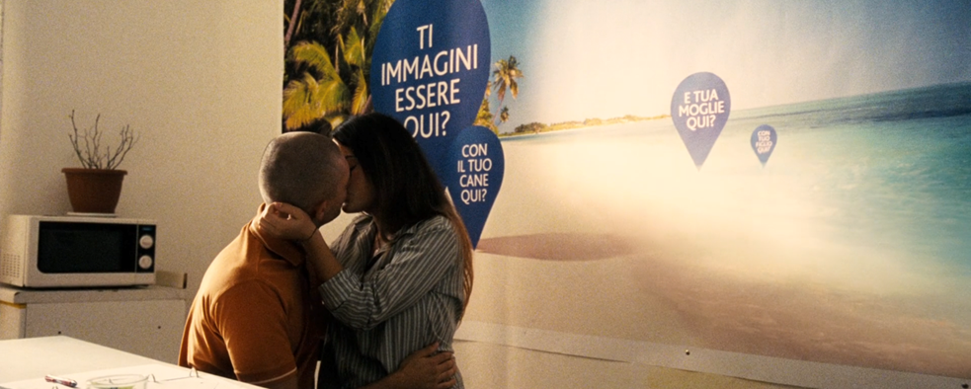

Fig. 1 Fig. 2

* The text reads: “Ti immagini essere qui” (Can you imagine yourself here?) “Con il tuo cane qui?” (With your dog here?) “E tua moglie qui? (And your wife here?). “Con tuo figlio qui?” (With your son here?).
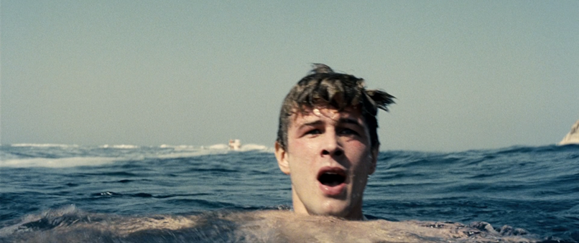
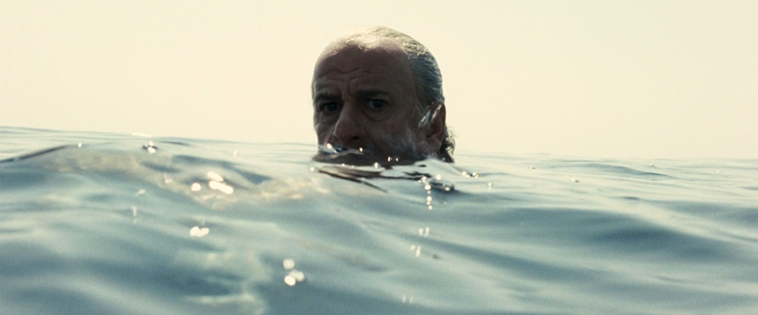
Fig. 3 Fig. 4
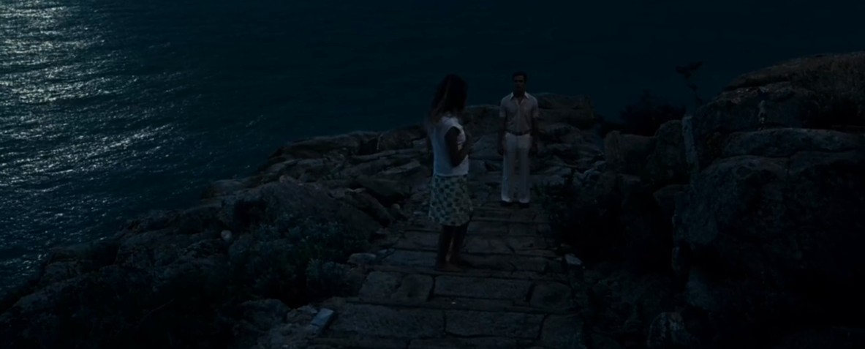

Fig. 5

2) After having viewed La grande bellezza, do you agree with Kilbourn’s assertion that the ‘Sorrentinian subject’ is nearly always completed by an enigmatic ‘Woman’ (class discussion & “The ‘Primal Scene’,” p. 381)? Is Elisa Jep’s salvation? What does Ramona represent for Jep? What role does she serve? What about the other female characters Jep frequents (lovers, friends, associates)? Include specific examples from the film. Write 5-7 sentences.

3) Do you agree with Asciuto’s claim that the terrazza (roof terrace) represents intimacy and hedonism in Italian films (“Intimacy and Hedonism: The Aesthetics of the Terrazza in Italian Cinema”)? In addition to these divergent qualities (intimacy- closeness, affinity, attachment, familiarity vs. hedonism- self-indulgence, pleasure-seeking, excess, luxury), does the cinematic space of the terrazza support the representation of other contradictions (“public” vs. “private”; “security” vs. “community”)? Has the function and semiotic purpose of the terrazza in Italian films evolved over time? Think about the roof terrace in the very first film we screened in ITA 375, Una giornata particolare (A Special Day, Scola, 1977) and this cinematic space in La grande bellezza (The Great Beauty, Sorrentino, 2013). Cite examples from Asciuto’s article (see pages 394-396; 401-405) in addition to your own observations. Write 5-7 sentences.

