PART I: BEFORE VIEWING
Otto e mezzo/ 8 ½ (look up missing info on IMDb)
Director:___________________
Year:

Cast
Character Actor/ Actress Giudo Anselmi
Claudia
Luisa Anselmi
Carla
Rossella
Gloria

1) Analyze the film poster. Who do you imagine the characters to be (occupations, relations/interrelations, challenges/solutions)? What do you think 8 ½ will be about? What might be the significance of the film title? Write a minimum of 3-5 sentences.

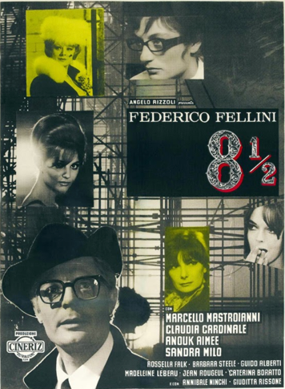

PART II: WHILE VIEWING

1) Pick one technique/element to focus on: music/sound, camerawork, symbolism/iconography. Describe how this technique/element is used in one scene. Be sure to jot down the minutes so you can re-view it and expand upon this response after viewing the film in its entirety. Write a minimum of 7-10 sentences.

PART III: After Viewing

1) Jacqueline Reich claims that “in terms of a male fantasy about women [8 ½] is decidedly uneroticized” (Beyond the Latin Lover: Marcello Mastroianni, Masculinity, and Italian Cinema, p. 87).

In his essay for The Criterion Collection film critic Alexander Sesonske avers:

[Fellini] used this [film] as an opportunity to probe the mystery of artistic creation and the problems of human relations created by a society whose traditional education portrays women as either sacred or profane, either mother or whore.
(https://www.criterion.com/current/posts/173-8-1-2-a-film-with-itself-as-its-subject)

Do you agree? Cite examples from the film as well as relevant points from class discission and the Playboy interview with Fellini. Write at least 5-7 sentences.

2) What role does humor play in dismantling/ subverting conventions of masculinity/ femininity in this film? Could the same message/ critique be portrayed without humor? How would the film change? Write 5-7 sentences.

3) Do you think the title, 8 ½, does justice to the film? Create an alternate title for the film. Explain why you think this title would be appropriate. Write a minimum of 3-5 sentences.

